Workbench Instance creation:

- Go to Agent Platform Workbench

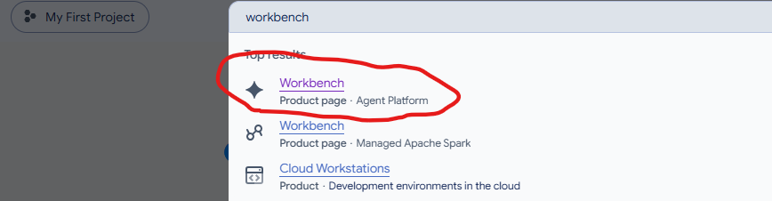

- Click on Create new and Uncheck ‘Enable Apache Spark and Big Query Kernels’ and Create Instance
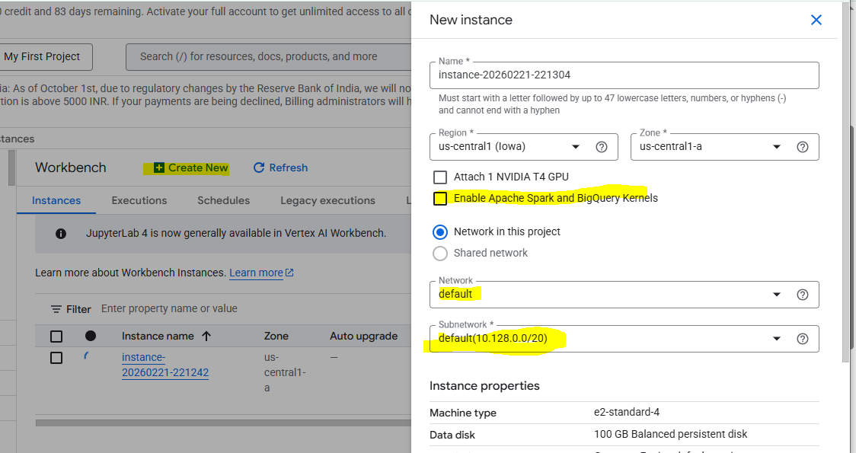

- Click on ‘Open Jupyter’ Lab link

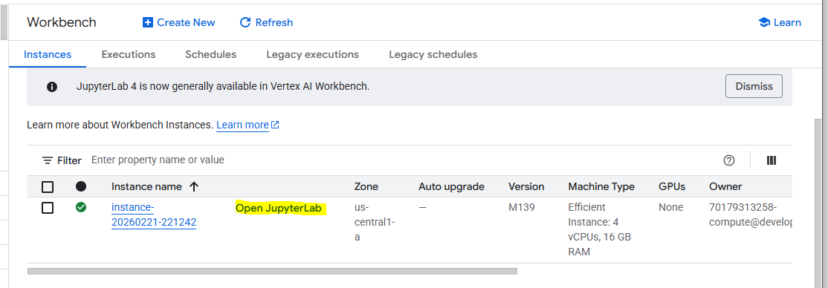

- You can see as below after clicking the Open Jupyter Lab

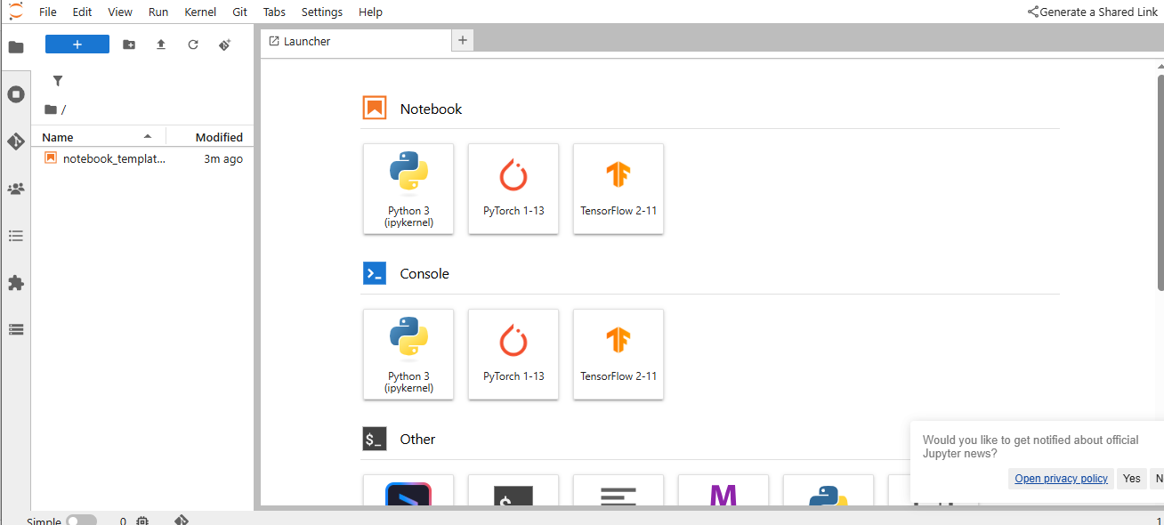

- Again, go back to instance and click on highlighted below Instance link
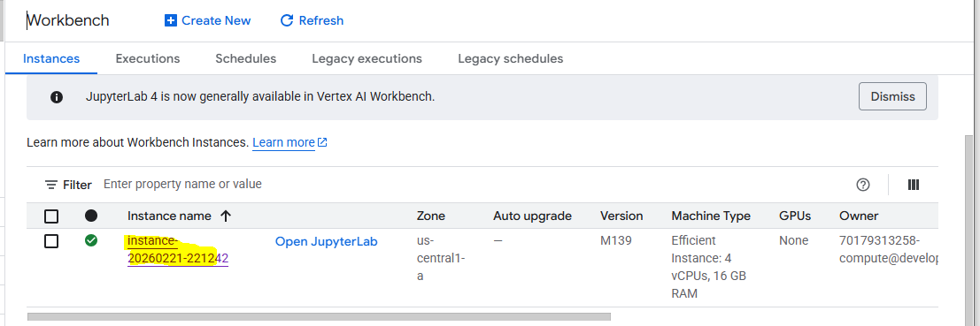

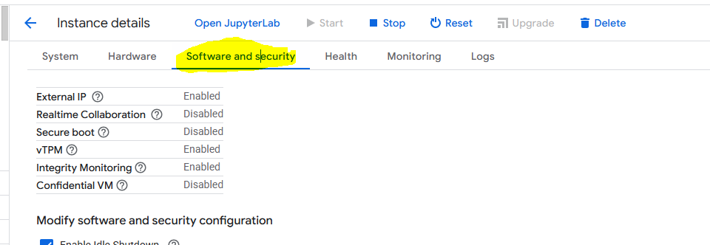

Change the time of inactivity before shutdown from 180min to 60min as below.
Click on Submit button

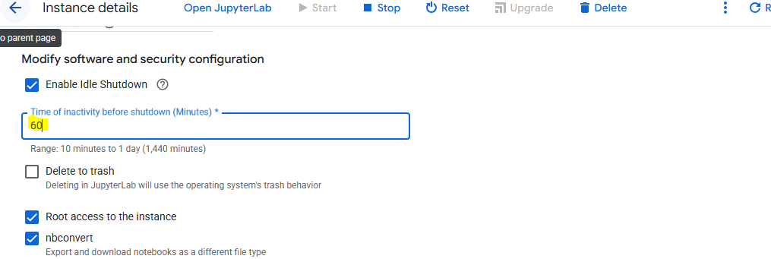

Permissions:

- Go to cloud.google.com and search for IAM.
- Pick the default compute account and click on the right to edit the roles “Edit principal”
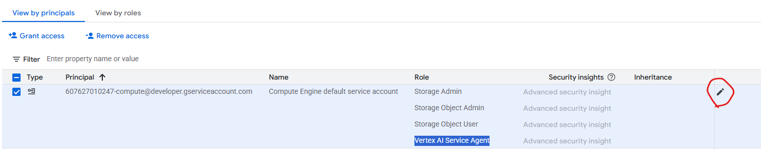

- Follow the below steps to add below roles one by one
- Vertex AI Service Agent/Administrator
- Storage Admin
- Storage Object user
- Storage Object Admin
- Agent Platform Express User (Beta)
- Cloud Run Admin API

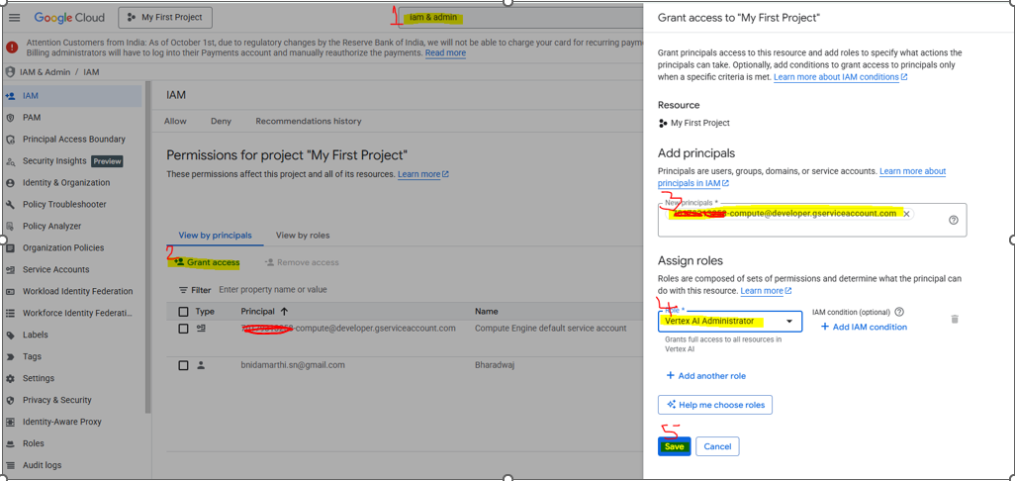

Enable Artifact Registry API & Create Artifact registry:

Enable the Artifact Registry API first: Search for this in Google console and enable.
Once enabled, it should reflect like this.
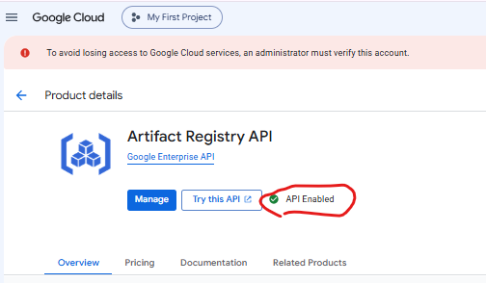
Then, create artifact registry with the ‘name’ of your choice. I’ve used “demo”.
Region as “us-central1” and click on create.
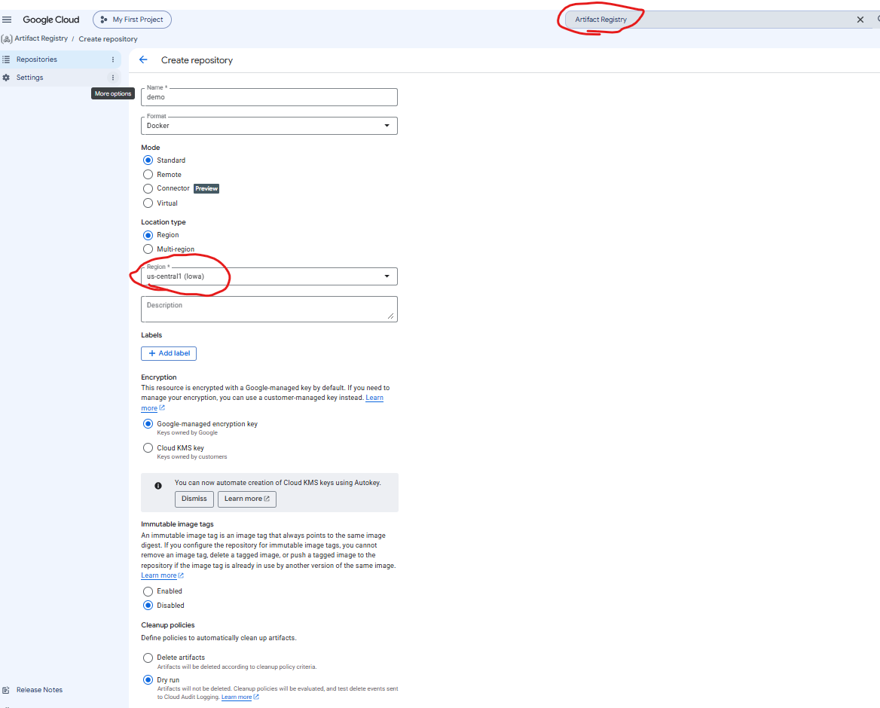

Once these pre-requisites are done, lets go with lab.

Implementation Lab:

Again, Click on Open Jupyter Lab, and add the files from git with all the deployment files which are shared in the below git repo and search for deployment folder.

https://github.com/SrinivasMadsi/AIBEES-6_Classes.git

Path : GenAI/7.RAG_Deployment
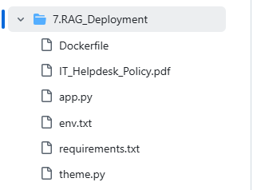

Below are the files which should reflect once you clone from the git.

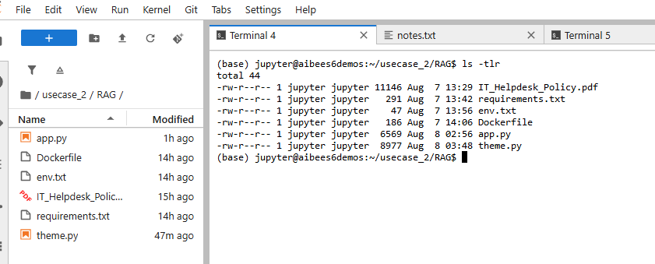

Open env.txt and update your GCP {project_id}

Docker steps ( containerization):

Build:
docker build -t rag-app-0808 .
(.) represents the current directory. Please ensure to do it in the same directory where the code files are.

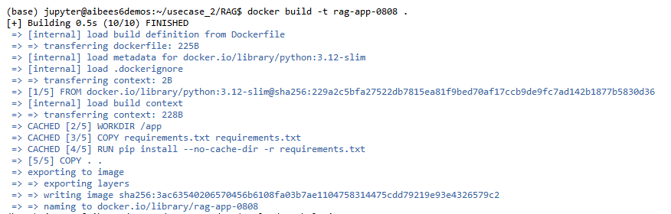

Go to artifact registry and copy the path from below and adjust the tag & push commands.

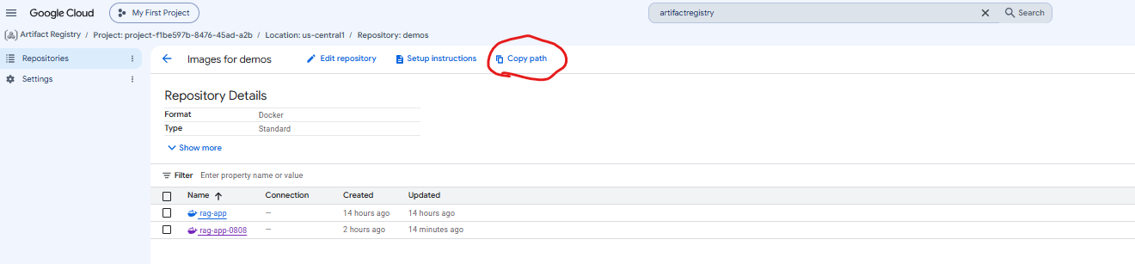

Tag:
docker tag rag-app-0808 us-central1-docker.pkg.dev/{project-id}/demos/rag-app-0808:v2

Push:
docker push us-central1-docker.pkg.dev/{project-id}/demos/rag-app-0808:v2

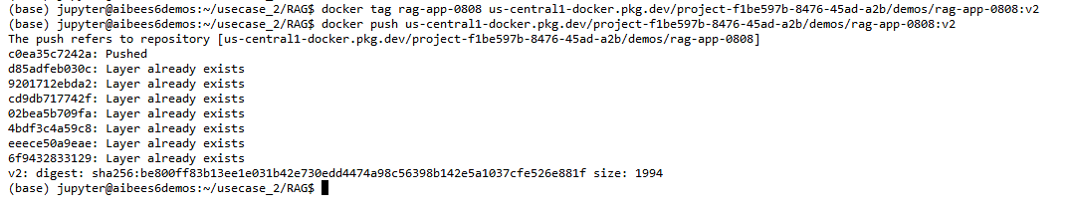

Auth (if push fails):

To fix the authentication error run the below command
gcloud auth configure-docker us-central1-docker.pkg.dev

Still facing error as below with permission denied
Run, gcloud auth login

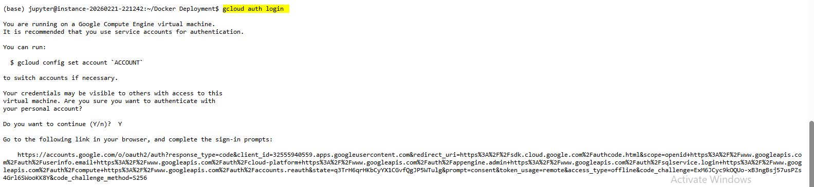
Copy the above URL and login with your account and copy the below blue area code

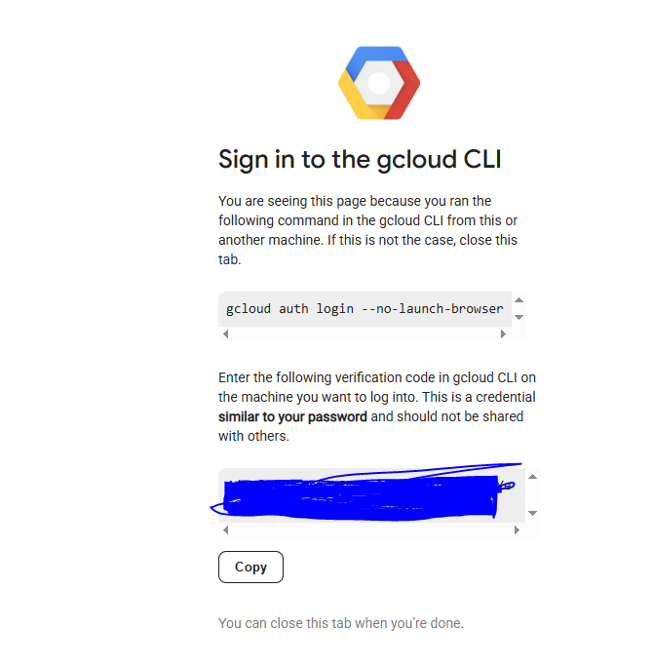

Paste the code in the terminal and execute the below commands again.

In my case, the docker image has been pushed to GCR under the below path

Artifact Registry path/GCR path:
us-central1-docker.pkg.dev/{project-id}/demos/rag-app-0808
Once images are pushed they should reflect as below.

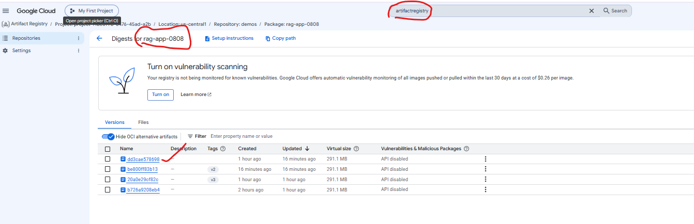

Deployment using Cloud Run:
Go to Cloud Run on GCP console and click as below
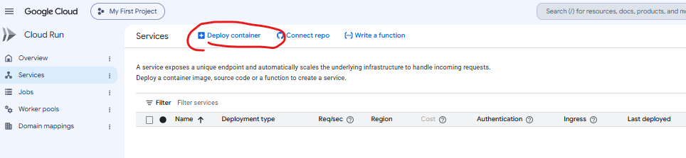
Click the below options and input a name to your service Eg: “rag-app”.
Then select on the yellow section to select the deployed container image.

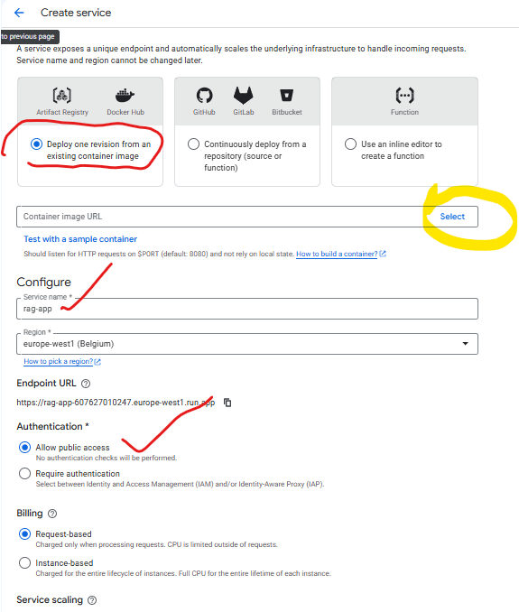

On the right side, you will get option to select the image, Please select as per the tags you’ve mentioned.

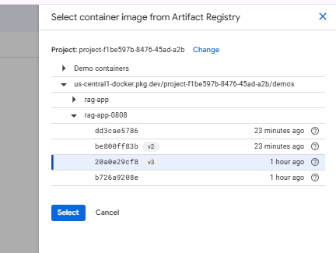

Once selected, scroll below for the highlighted options and click on create.

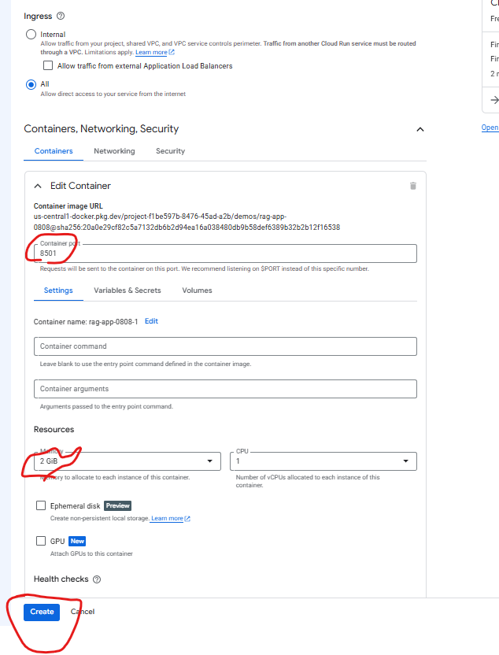

While deployment is in-progess.

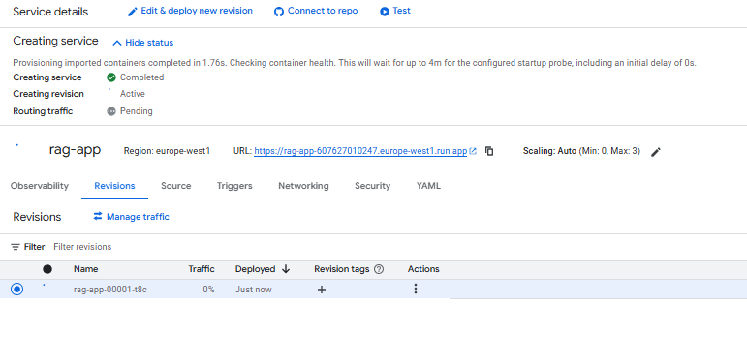

Once deployed, you will have the URL/endpoint.

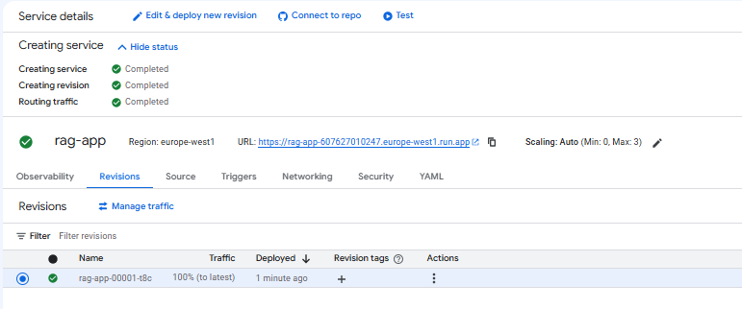

Click on the endpoint and test it by uploading the file and ask questions..

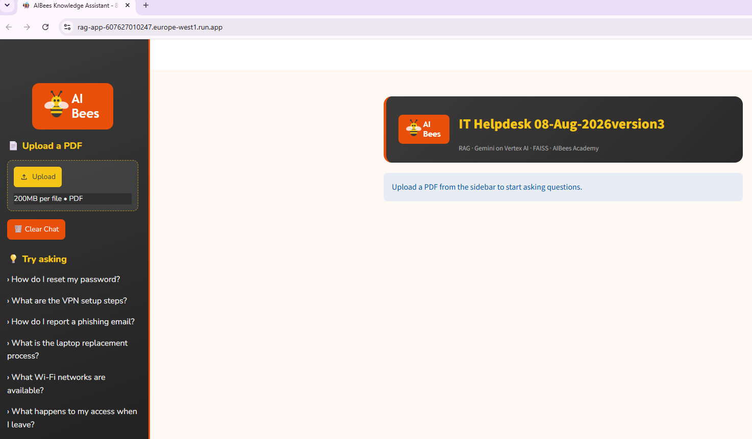

After this, try a canary deployment with a revised tag and test it.

Delete the Cloud Run services after the testing to avoid the consumption of tokens.

